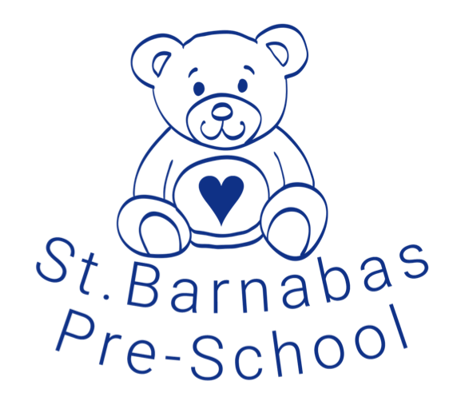
St Barnabas Pre-School’s Safer Recruitment Policy

Policy Statement
St Barnabas Pre-School is committed to providing a happy supportive working environment to all its members of staff. The Pre-School recognises that, in order to achieve these aims, it is of fundamental importance to attract, recruit and retain staff who will share this commitment.

The aims of our Safer Recruitment Policy are as follows:
- To ensure that the best possible staff are recruited on the basis of their qualifications, experience, abilities and suitability for the position.
- To ensure that no job applicant is treated unfairly on any grounds including race, colour, nationality, ethnic or national origin, religion or religious belief, sex or sexual orientation, marital or civil partner status, disability or age.
- To ensure compliance with all relevant recommendations and guidance.
- To ensure that the pre-school meets its commitment to safeguarding and promoting the welfare of children and young people by carrying out all necessary pre-employment checks.

Recruitment and Selection procedure.
All applicants for employment will be required to complete an application form containing questions about their academic and employment history and their suitability for the role. A Curriculum Vita will not be accepted in place of the completed application form.

All applicants will be provided with a job description that clearly states the main duties and responsibilities of the post and the individual’s responsibility for promoting and safeguarding the welfare of children, and that all positions are subject to enhanced DBS checks.

An applicant may then be invited to attend a formal interview at which their relevant skills and experiences will be discussed in more details, the interview will also include supervised time interacting with our children.

If it is decided to make an offer of employment following the formal interview, any such offer will be conditional on the following:
- The receipt of two satisfactory references (one of which must be from the applicant’s most recent employer) which the pre-school considers to be satisfactory.
- The receipt of an enhanced DBS check
- Staff sign a disclosure that they are fit to work and have no undeclared medical or physical conditions which could prevent them fulfilling their duties.
- Proof of the applicant’s identity and right to work in the UK.
- Proof of the candidate’s qualifications, academic and vocational, as claimed on the application form.

